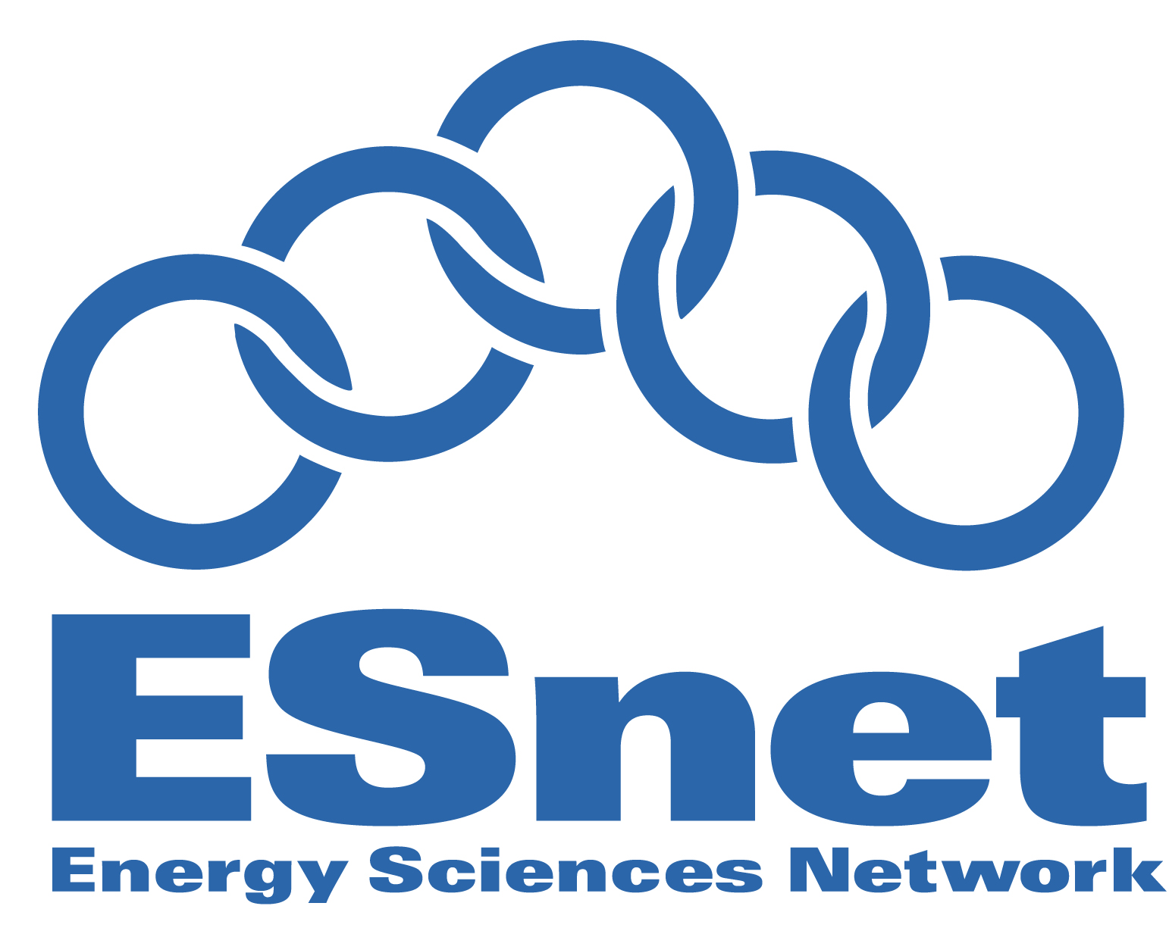
Posted: October 27, 2008
Princeton’s New High-speed Connection to ESnet’s Dynamic ESnet4 Network
BERKELEY, CA – The U.S. Department of Energy’s Energy Sciences Network (ESnet) just improved its Internet connections to several institutions on Princeton University’s Forrestal Campus, including the Princeton Plasma Physics Lab (PPPL), the High Energy Physics (HEP) Group within the Physics Department at Princeton University, and the National Oceanic and Atmospheric Administration’s Geophysical Fluid Dynamics Laboratory (GFDL).
Now researchers around the globe can access data from these science facilities with increasing speeds and scalability, helping enable international collaborations on bandwidth-intensive applications and experiments.
“This is a great achievement,” says Steve Cotter, head of ESnet. “With the availability of cutting-edge instruments and supercomputers, scientists around the world are collaborating to carryout large experiments that produce tremendous amounts of data. This upgrade links Princeton’s physics researchers to that data through our robust and reliable network, ESnet4, via point-to-point dedicated circuits and IP services at multiple gigabit per second speeds.”

The Princeton network upgrade took approximately five months to complete, and involved running fiber optic cabling underground from the Forrestal Campus outside Princeton, New Jersey, along Route 1 to South Brunswick, then to Philadelphia where it is transported across the ESnet infrastructure to ESnet's main point of presence in McLean, Va.

On the Princeton campus, the PPPL's Internet connection is now operating at 10 gigabit speeds, 10 billion bits per second, significantly faster than its previous speed of 155 megabits, or 155 million bits per second. This is a 6,400 percent improvement in performance, and ESnet’s international connectivity will facilitate collaborations on world-class facilities, including the future ITER fusion reactor in France and existing fusion energy facilities such as the superconducting tokamaks in Korea (KSTAR) and in China (EAST).

Meanwhile, the upgrade brought a new 1 gigabit circuit to GFDL, providing high speed access to other ESnet sites such as the Oak Ridge National Laboratory's Leadership Computing Facility, where advanced climate simulations will be carried out. The HEP Group in the Physics Department also received its own 1 gigabit circuit, allowing it to access data from Europe’s Large Hadron Collider (LHC). Based at the European Center for Nuclear Research (CERN) in Switzerland, LHC is the world’s largest particle accelerator. Over 15 million gigabytes of data per year will be distributed to researchers across the globe, when the LHC begins smashing together beams of protons to search for new particles and forces, and beams of heavy nuclei to study new states of matter. The ESnet4 network plays a significant role in providing access to this data for U.S. researchers.

“This world-class network capability places the Princeton institutions on par with the upper echelon of research institutions and allows researchers to collaborate with institutions around the world at speeds necessary to conduct large scale science,” says Joe Burrescia, General Manager for ESnet.

This upgrade is a collaborative effort involving the U.S. Department of Energy (DOE), National Oceanic and Atmospheric Administration (NOAA), the University of Pennsylvania, and Princeton University. Internet2’s regional connector, MAGPI, based at the University of Pennsylvania will coordinate and manage the multi-agency consortium that connects Princeton to the ESnet4 network. The DOE and NOAA equally shared the cost of the fiber installation to Princeton institutes, while the University contributes to the on-campus cost of the optical equipment.
About ESnet and Berkeley Lab
ESnet is funded by the DOE Office of Science to provide network and collaboration services in support of the agency’s research missions. A pioneer in providing high-bandwidth, reliable connections, ESnet enables researchers at national laboratories, universities and other institutions to communicate with each other using the collaborative capabilities needed to address some of the world’s most important scientific challenges. The ESnet Department is part of the Computational Research Division at Berkeley Lab. For more information about ESnet visit http://www.es.net/.
Berkeley Lab is a U.S. Department of Energy national laboratory located in Berkeley, California. It conducts unclassified scientific research and is managed by the University of California. Visit our website at http://www.lbl.gov.
Contact: Linda Vu, 510.359.2402, LVu@lbl.gov

###

